When is it NOT a function?

- Mapping diagrams
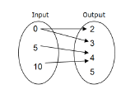
When there is MORE THAN ONE ARROW connecting an INPUT (x value) to an OUTPUT (y value), it is NOT A FUNCTION. The input 0 has two arrows, one to an output of 2 and another arrow with an output of 3, so this is NOT A FUNCTION.

- Table of values
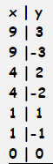
When the x value REPEATS and has DIFFERENT y values, it is NOT A FUNCTION. The x values 9, 4 and 1 repeat and each have two different outputs, so this is NOT A FUNCTION.

- Graph

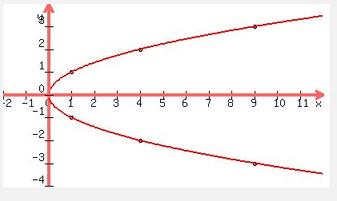

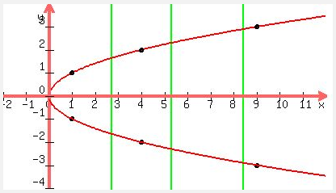

When the graph DOES NOT PASS THE VERTICAL LINE TEST, it is NOT A FUNCITON.

- Set of coordinate points
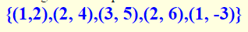
When the x value REPEATS and has DIFFERENT y values, it is NOT A FUNCTION. The x value of 2 repeats and has two different y values: 4 and 6, so this is NOT A FUNCTION

