Solving and Graphing Inequalities

For each of the following inequalities, tell whether x = 5 could be a possible solution.
- $5x-2>25$ 2. $4-3x<5$ 3. $\frac{x-9}{2}≥-2$

For each of the following inequalities, solve for x and graph the answers on the number line.
- $5x>-20$ 2. $x-4≤-2$ 3. $4x+3<-1$

4. $8-3x<-4$ 5. $-2x+7≥9$ 6. $\frac{x-7}{2}>-2$

For each of the following inequalities, tell whether the point (5, -3) could be a possible solution.
- $y>2x-4$ 2. $y<-\frac{2}{5}x-1$ 3. $y≥-3x+4$

Graph the following inequalities on the coordinate plane.
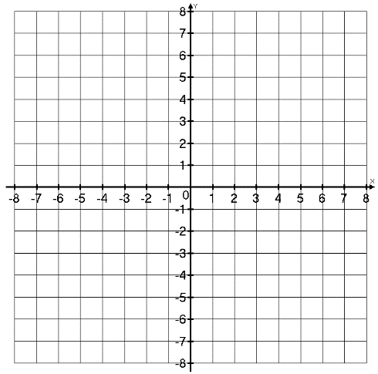
- $y>2x-4$ 2. $y<-\frac{2}{5}x-1$ 3. $y≥-3x+4$

