What you need to know and be able to do | Things to remember | Problem | Problem
Describe Characteristics of Exponential Functions | - Interval of Inc/Dec  - Domain  - Range  - Asymptote  - B ____ 1  - Growth/Decay  - X-int  - Y-int  - End behaviors  - Rate of Change  $$\frac{y_{2}-y_{1}}{x_{2}-x_{1}}$$ | 1.  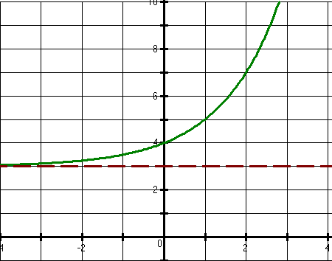 | Domain:  Range:  Asymptote:  X-int: Y-int:  Int. of Increase or Decrease  B ____ 1  Growth or Decay  End Behaviors:  Rate of Change from  0 < x < 2
 |  | 2.  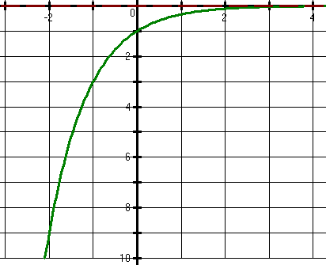 | Domain:  Range:  Asymptote:  X-int: Y-int:  Int. of Increase or Decrease  B ____ 1  Growth or Decay  End Behaviors:  Rate of Change from  -2 < x < 0
Identify Transformations of Exponential Functions | - Describe the transformations on the parent function y = 2^{x} | 3. $y= -2{\left(2\right)}^{x-3}$ | 4. $y=\frac{1}{3}{\left(2\right)}^{x}+8$
 | - Write the equation for the function y = 3^{x} with given transformations | 5. Vertically compress by a factor of 1/3, shift left 3, and shift down 8 | 6. Reflect across the x-axis, vertically stretch by a factor 5, and shift up 7
Graph Exponential Functions | - Use -2, -1, 0, 1, 2 for the x-values  - Graph the asymptote | 7. $f\left(x\right)=-2{\left(\frac{1}{2}\right)}^{x}+5$  x f(x) | 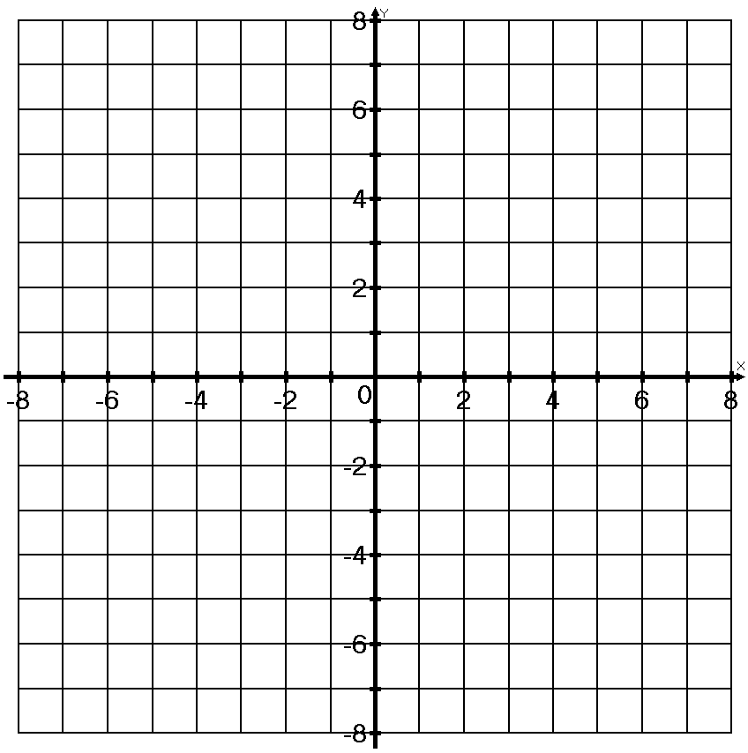
8. $g\left(x\right)={\left(3\right)}^{x+2}$
x | f(x)

Comparing exponential characteristics | - Compare y-intercepts  - Compare rates of change | Use the graphs from Problems 7 and 8
 |  | 9. Which function has a greater rate of change from 0 < x < 2? Why? | 10. Which function has a lower y-intercept? Why?
Solve Exponential Functions | - Isolate the base  - Create like bases | 11. $7^{x-9}={49}^{2x-3}$ | 12. ${64}^{3x+5}={1024}^{x}$
 |  | 13. $6^{x-3}+5=41$ | 14. $8^{3x-1}-3<13$
Create and Use Exponential Functions from word problems and tables | - Find your initial value ‘a’ (x = 0)  - Calculate your rate ‘b’  - If there are percentages, it is either (1 +r) or (1 – r) | 15. The population of Marietta in 2003 was estimated to be 35,000 people with a rate of increase of about 24%.  - Write an equation to represent the population of Marietta.  - Use your equation to estimate the population in 2015 to the nearest hundred people. | 16. A certain bacteria that is growing on your kitchen counter doubles every 5 minutes. Assuming that there was only 1 bacteria in the beginning, how many bacteria would there be after 2 hours?
 |  | 17. Chyna invests $300 at a bank that offers a rate of 5% compounded quarterly.  - Write an equation to model the amount of money in Chyna’s bank account.  - How much money will Chyna have in 4 years? | 18. Caleb bought a new car at a cost of $25,000. The value of the car decreases about 25% every 2 years.  - How much will his car be worth about 2 years?  - How much will his car be worth after 10 years?
 |  | 19. Tina and her friends are having a party. The amount of people that know about the party throughout the week is shown in the table below.  Number of Days Number of People  0 6  1 18  2 54  3 162 | - Write the equation of the amount of people that know about the party.  - How many people will know about the party in a week?
Create and Use Geometric Sequences | - Recursive Rule:  $$a_{n}=r*a_{n-1}$$  - Explicit/Closed Rule:  $$a_{n}=a_{1}{\left(r\right)}^{n-1}$$ | 20. Given the sequence below:  152, 76, 38, …  - Use the recursive rule to find the 5th term  - Create the closed formula for the sequence.  - Use the explicit formula to find the 8^{h} term | 21. Given  $a_{1}=-2$ $a_{n}=2a_{n-1}$  - Find the first 5 terms of the sequence.  - Create the explicit formula.  - Calculate the 8th and 10th terms.
Compare Exponential functions in different forms | - Find the characteristics of each function in its own form. Use those characteristics to compare  - Y-intercepts occur where x = 0  - Rate of change requires 2 points to plug into the slope formula  - Greater rate of change is the magnitude of the number, not the sign | F(x) is represented by the graph below  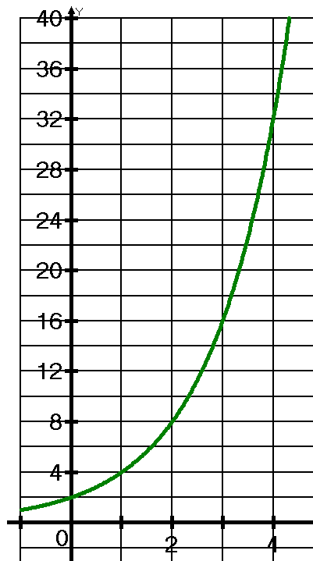  G(x) is represented by the equation  $$G\left(x\right)=1{\left(3\right)}^{x}$$ | What is the y-intercept of f(x)?  What is the y-intercept of g(x)?  Which function has a lower y-intercept?  What is the rate of change of f(x) for 0 ≤ x ≤ 3?  What is the rate of change for G(x) for 0 ≤ x ≤ 3?  Which function has the greater rate of increase for 0 ≤ x ≤ 3?

