Directions: Farmer Bob is planting a garden this spring. He wants to plant squash, pumpkins, corn, beans, and potatoes. His plan for the field layout is shown in the figure below. Use the figure and your knowledge of polynomials, perimeter, and 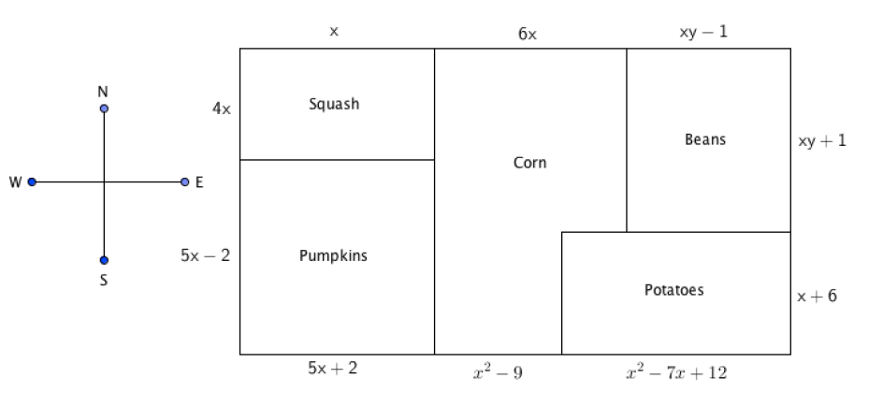area to solve the following. Circle all final answers.
6x
4x
5x - 2
$$xy+1$$
$$xy-1$$
$$x+6$$
$$x^{2}-7x+12$$
$$x^{2}-9$$
5x + 2
5x + 2

- Write an expression that represents the length of the south side of the field (2 pts).

- Simplify the polynomial expression that represents the south side of the field. (3pts)

- Write an expression that represents the length of the west side of the field. (2pts)

- Simplify the polynomial expression that represents the south side of the field. (3pts)

- Write a polynomial expression that represents the perimeter of the pumpkin field. (2pts)

- Simplify the polynomial expressions that represents the perimeter of the pumpkin field. State ONE logical reason why the perimeter would be useful to Farmer Bob. (3pts)

- Write a polynomial expressions that represents the AREA of the squash field (use parenthesis). (2pts)

- Simplify the polynomial expressions that represents the area of the squash field. State ONE reason why the calculated area would be useful to Farmer Bob. (3pts)

- Write and simplify the polynomial expressions that represents the area of the bean field (use parenthesis). (3pts)

- Farmer Bob wants to put a fence around his potato field, using what you know about perimeter how much fencing would Farmer Bob need? Please leave the expression in its simplest form. (3pts)

- Identify the number of terms:___________(1pt)
- Identify the variables:_________________(1pt)
- Identify the coefficients:_______________(1pt)
- Identify the constant:_________________(1pt)

Bonus (5 pts)
Write and simplify polynomial expressions that represent the area and perimeter of the cornfield.

Area:_____________________ Perimeter:________________

