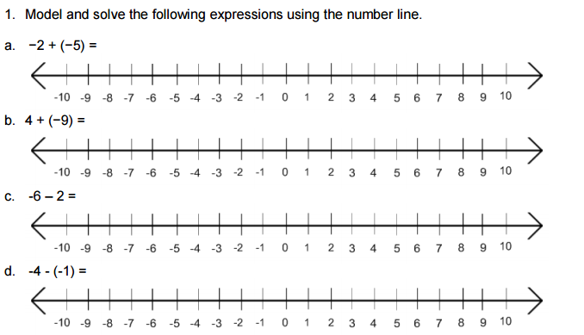

Name:____________________________ Integers Homework

