- Rebecca needs to divide ¾ by 3. | - How far is -8 from 3? | - The temperature on Wednesday was $-33℉$ on Thursday and on Friday it was $-17℉$ warmer, what was the temperature on Friday?
- What is the prime factorization of 81? | - Name 6 prime numbers? | - Describe composite numbers and give an example.
- Is 451, 672 divisible by 3? | - What is an equivalent fraction to ¼ ? | - What is $2\frac{4}{5}$ as an improper fraction?
- 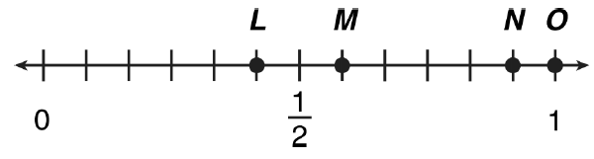 What point is at $\frac{5}{12}$? | - The recipe for fudge brownies calls for ¼ of flour. Mariella wants to double the recipe. How much flour will she need? | - $\frac{7}{15}-\frac{3}{15}=$
- $13 ×\frac{2}{5}$ | - $\frac{6}{4}×\frac{2}{3}$ | - Which number is the closet to zero?  - 0.008  - $\frac{1}{10}$  - 0.01  - $\frac{1}{2}$

- How far is -9 from 6? | - (-2)(-9)= | - 24$÷-3$=
- What is true about $-\frac{2}{-3}?$ | - (-3)+6= | - 5+2 (6-3)² which operation would you do first?
- Teresa wants to buy a piece of candy 0.25 cents, a ball for $1.75, and a bag of chips for 0.75 cents. How much money does she need? | - $4+4÷2+1=$ | - Is $π$ a rational number or irrational number, why?
- 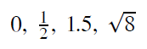Does the following set include only rational numbers, why? | - 2.56 x 10⁵ is equivalent to what number? | - 6 x 10⁻⁴ is what in standard notation?
- The square root of 51 is between which two whole numbers? | - Write 0.000345 in scientific notation. | - Write 786,483 in scientific notation?

