Monday  Date:___ | 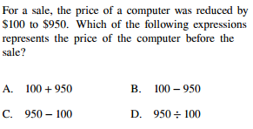 |  | Test Taking Strategies
Tuesday  Date:______ | 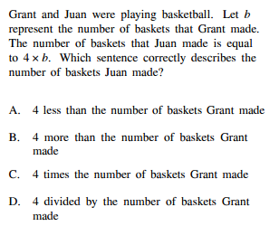 |  | Test Taking Strategies
Wednesday Date:______ | 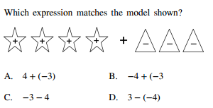 |  | Test Taking Strategies
Thursday  Date:________ | 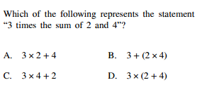 |  | Test Taking Strategies
Friday  Date:_____ | 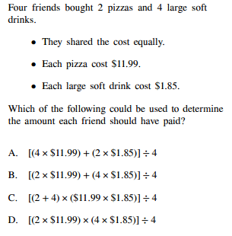 |  | Test Taking Strategies

