Week 3 Day 1 Notes
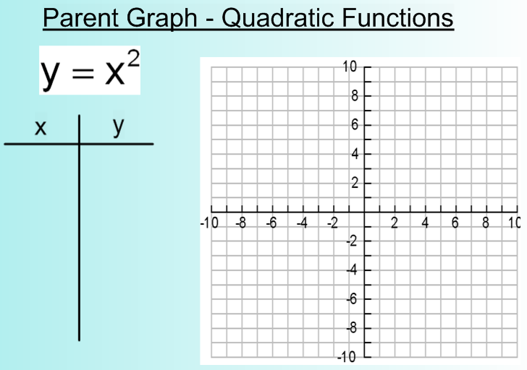
The graph formed is called a ______________________ which is always in a _____ shape!
3 forms of a quadratic:
Standard - y = ax² + bx + c
Vertex - y = a(x - h)² + k
Intercept - y = a(x - p)(x - q)

Besides x, what variable do ALL three forms have in common?

Min/Max
*If "a" is _______________ the graph has a _____________ value (graph opens ______)

*If "a" is _______________ the graph has a _____________ value (graph opens ______)

Which way would these quadratics open up?
Will the graph have a min or max?

Ex 1. y = 2x² - x - 7

Ex 2. y = -(x + 5)² - 9

Ex 3. y = 3(x + 2)(x + 7)

Vertex:
*The ___________ of the parabola is the highest (maximum) or lowest (minimum) _________ on the graph.

*The vertex's _______________ is the MAXIMUM or MINIMUM value of the graph (________).

*The vertex's _______________ is the ________________ (_______).
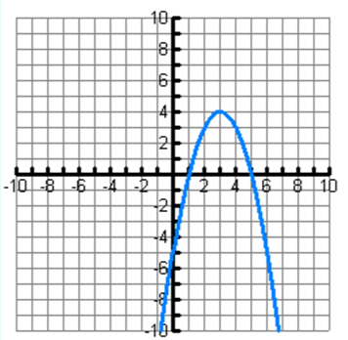
* ____________________ -

The ___________ line that divides the parabola into

mirror images through the ___________

x-intercepts
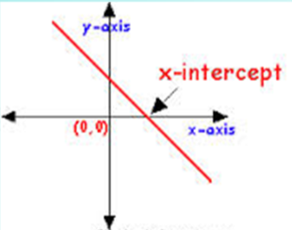
The x-intercepts of ANY function are the point(s) where the graph of the function crosses _________________

*For a x-intercept, the y-value of the point is _____!*

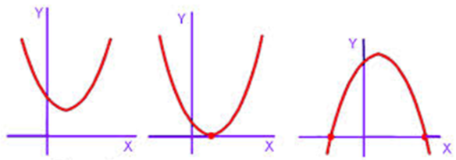
Zeros/Roots
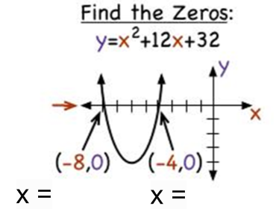
The zeros/roots of ANY function are the
________________ of the function written
_______________________________

y-intercepts
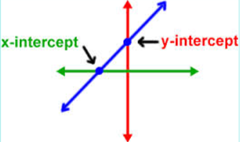
The y-intercepts of ANY function are the point(s) where the graph of the function crosses _________________

*For a y-intercept, the y-value of the point is _____!*

If you can't identity the y-intercept on the graph, plug in______ for ____ and _______ for ____.

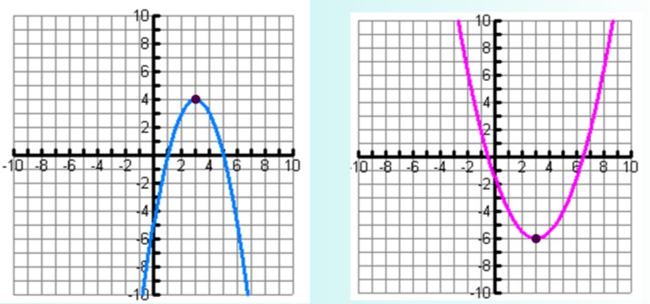
EXAMPLES:

